[From the Author of “Poems by Kolki – Absolutely Humane”, “Real Path To 9/11” & “Sayings of Kolki”]

Planet Earth
(Dedicated to sustainable healthy planet earth – Deepak Sarkar, www.kolki.com)
<Related Poems: Day of Thinking EARTH Pine Tree Pollution Garbage Recycling Day of Consciousness>

In this vast universe
Among seemingly infinite space and distant stars
I am the living Planet Earth
Revolving merrily as family around my star, the Sun!

I have been living for ages caring for millions
Mineral, oil, gas deposits act like my organs!
My soil is fertile to satisfy being of all forms
Plants, insects, birds, and animals!
My oceans are mechanisms for atmospheric balance
Ensuring a predictable life support system immortal!

While most sentient being respect my natural order
Humans need mining, drilling, and logging, for life and culture!
But the entrepreneurial ambitions for material gains of lust
Resembling my existence as decapitated body parts!

So it is time for humans to ask -
Is it alright to siphon last drop of oil sheltered by the rock?
Is it alright to clear cut and uproot old growth to log?
Is it alright to extract metallic ores creating miles of holes?
Don’t they unitedly constitute their living abode?

It is time for humans to understand -
Thousands of years prepared my body for genetic evolution
Soon to be hostile place to live for generations!
That time may be running out to fix my scars from self healing
Making me slip/wobble during daily spin
Producing unpredictable day, night, and seasons!

If humans continue drilling, logging, mining for greed
Transferring earth around for quick profit
Induced imbalance may soon affect axial inclination
Causing enormous calamities leading to global devastations!
Depriving world from solstices, equinoxes, and celebrations
Resulting in permanent summer or winter in many regions
Triggering endless migrations, wars, and annihilations!

Hope ‘Earth Day’ becomes a day of global consciousness
Respecting unison with the spirit of peaceful coexistence!

About Kolki ☼Kolki Peace Foundation☼ Why Kolki?
Author: Deepak Sarkar, 844 Royal Oak Ave, Victoria, BC V8X 3T2, Canada; Tel/Fax: 250-412-2897;
E-Mail: Deepak.Sarkar@ieee.org; Poetry & Peace Web Site: www.kolki.com
Sayings of Kolki Truth GLOBAL ISSUES
(Written: April 19, 2008)

[God (Universal Loving Expression) once blessed human giving them a brand new world, pristine environment, hospitable Native people, and sages with cosmic wisdom! Kolki]

Utopia Best Participatory Democracy Democratic Security One World Better World

Religion Global Solidarity Harmony PEACE Moonless
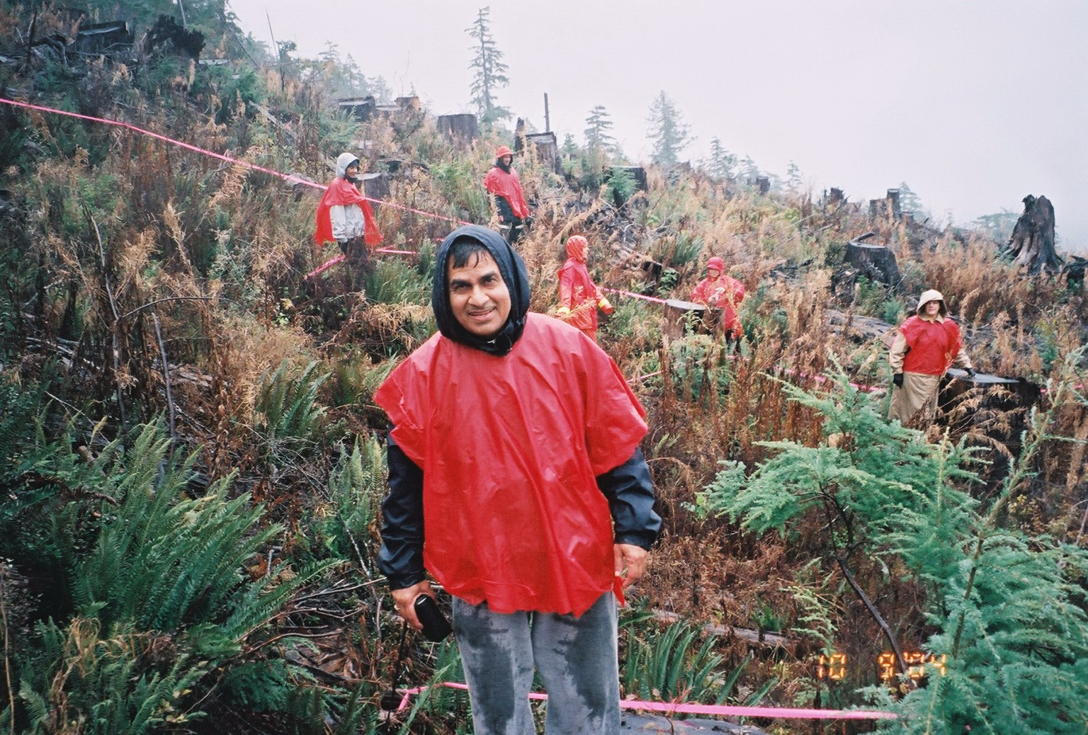

An economy based on defense industries, oil, real estate, carbonated drinks, pornography, logging, wars and re-construction … only leads to more infighting and overall worldwide destruction and dehumanization! Kolki

Fig. Clear cut at BC, Canada Rain Forest

Poem: Heir

