[From the Author of “Poems by Kolki – Absolutely Humane”, “Real Path To 9/11” & “Sayings of Kolki”]

Peace Now
(Dedicated to Universal Peaceful Co-Existence – Deepak Sarkar, www.kolki.com)
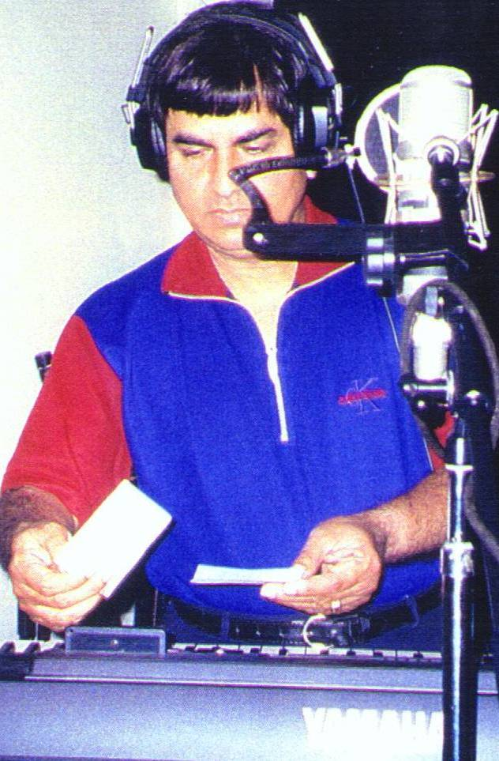
Watch Youtube Video: www.youtube.com/watch?v=RkuZD3l4VzQ

Click for Song: Composition & Computer Recorded Voice of Kolki

Related Songs: Heavenly Co-Existence Universal Celebration

NewPearlHarbour (9/11 False Flag Operation Motives and Means)

Peace now, peace now, peace right now -
No more war, no more war, no more aggression!

Peace now, peace now, peace right now -
No more bombs, no more missiles, no more occupation!

Truth now, truth now, truth right now
Collateral damages are death and destruction!

Peace now, peace now, peace right now
No more lies, no more pretexts, no more deception!

Truth now, truth now, truth right now
We all know who have weapons of mass destruction!

Peace now, peace now, peace right now
Peace is a direct threat to militarization!

Truth now, truth now, truth right now
Unilateralism could end civilization!

[The universal equation of peace from Kolki:
International Conflicts Minus (-) Super Power/Monarchical Strategic Interests = Lasting Peaceful Coexistence!]

About Kolki ☼Kolki Peace Foundation☼ Why Kolki?
Author: Deepak Sarkar, 844 Royal Oak Ave, Victoria, BC V8X 3T2, Canada; Tel/Fax: 250-412-2897;
E-Mail: Deepak.Sarkar@ieee.org; Poetry & Peace Web Site: www.kolki.com
Sayings of Kolki Truth GLOBAL ISSUES

[Let us remind the World Preaching Domination is Terrorism; Acting to Achieve it is War Crime! …….. Kolki]

Article: “Known Weapons of Mass Destruction Around the World”

<Related Poems>
“War Crimes” “Bully” “War of Terror” “Terrorism” “War” “Democratic Magic” “New Pearl Harbour” “Inconvenient Truth”
“Intelligence” “Democracy” “American Orange Revolution”
“International Republican Party” “Guantanamo Bay”

<Related Articles>
“What Is Al-Qaeda?” “9/11 Truth Smoking Guns”
“Remote Military Hijacking”
“Deceiving Nobel Peace Awards”
“Why Mainstream Media is Silent?”

[World citizens, including Academics & Scholars, must not be naïve anymore! Illegal Invasion of Afghanistan and Iraq by US/Allied Forces were nothing less than real Terror and War Crimes. Unpunished for their heinous crime in 21st Century, the US military and Administration along with Israel are planning to repeat the crimes openly declaring their intention to strike against peaceful Iran as their option to Recolonize the entire world as “New World”, destroying ancient people, their vibrant creative cultures, and civilizations as collateral damages. It is time to remind world leaders that the world citizens know who have the most weapons of mass destruction and who use them conveniently violating international laws and using un-democratic United Nations. We must never compromise rule-of-law and proof-of-conviction for the sake of true democracy and lasting peace. Kolki]

Poems:
Cancerous 9/11 Hijacking

Fittest? Conflict Fallen Soldiers Why They Fight?

Common Ground Better World Best

[Terrorism can never be fully addressed without eliminating brutal military terrorism! Kolki]

Do we need a UN Security Council and an International Court which cannot Punish War Criminals in Bush, Blair and Howard Administrations for illegally attacking and destroying sovereign peaceful Iraq, killing and displacing millions? Kolki

Poem: DANGEROUS WORLD SITUATION

Love is the ultimate security which does not require expensive idle mischievous covert intelligence, violent military, destructive Defense industries, and divisive ideologies! Kolki

One World Global Solidarity Participatory Democracy Harmony

[For Peace: Vedic Chanting Hymn like simulation]

